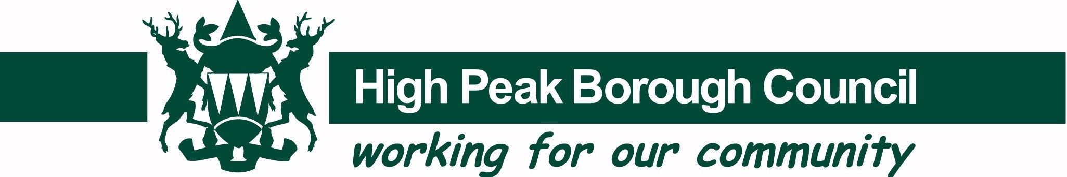

Media Release

23 September 2019

Getting recycling right in High Peak
It’s Recycle Week this week and the Borough Council is encouraging everyone to take a look at what they’re throwing away and check whether any of those items could actually be recycled.

Environmental concerns have never been so important to the nation and this year’s annual Recycle Week (23 to 29 September) is capitalising on this heightened awareness.

Recycling an item rather than throwing it in the general rubbish means it is dealt with in an environmentally friendly way, keeping materials in use and out of the environment.

Last year’s campaign saw an increase in the number of people motivated to recycle with more and more people recycling items such as plastic drinks, cleaner, toiletry and shampoo bottles alongside glass and tin cans. Many people cited environmental concerns as the main reason for doing so.

And households across the High Peak can get involved and do their bit. The Council’s top tips include:

- Recycle shampoo and shower gel bottles, toilet roll middles and tissue boxes and bathroom aerosols in your brown bins
- Nappies, plastic bags and film, black plastic items and containers with food or drink still in them should NEVER go in brown bins
- Put your food waste in the green bin either loose or in a compostable bag with the standard of EN13432 code and the seed logo.

Councillor Jean Todd, Executive Councillor for Climate Change and the Environment, said: “Our recycling rate in High Peak is 48% and it’s great that so many of us are recycling our waste – but we can do even better!

“People are increasingly aware of the impact our actions have on our environment. Recycling is a simple way we can all contribute to reducing that impact so we’re using this national week of action to encourage all our residents to recycle more – and to make sure we’re all getting it right.

“We can collect a wide variety of everyday household items for recycling and there’s a handy guide to what we collect and which bin to put it in on our website. Take a look and see if you’re throwing things away which could be recycled and help us raise our recycling figures even higher!”

If you’re unsure about a specific item it’s easy to check online at www.highpeak.gov.uk/BinsHelp

ENDS

HPBC Media Release Contact: Carolyn Sanders
Mobile: 07595 270937
Email: carolyn.sanders@highpeak.gov.uk
Web: www.highpeak.gov.uk
Facebook: www.facebook.com/highpeakbc Twitter: @HighPeakBC

