Bridge Mills / Willow Gardens Housing Development
Dear Residents,
I have agreed with the site manager at the Bridge Mills/ Willow Gardens housing development that he will keep us updated as to the expected schedule of works on site each week so that we know what to expect and hopefully disruption can be minimised.The expected works for week commencing the 7th October are:
- Urban Regen are continuing with remediation and turnover of original fill materials. Removing waste and recycling from site.
- Urban Regen are preparing roads prior to further roads and sewers works taking place.
- NW Argyle are completing roads and sewers works to the second estate road.
- MKC are continuing installing foundations for housing and cropping piles.
- Barratts utility contractor are continuing to install services throughout the site.
- A road sweeper will be in operation to keep the road and site entrance clean but minimal mud is expected on the road.
- Traffic management will be in operation at the bridge for approximately 2 weeks. Temporary lights will be in place to allow utility providers to carry out connection works
Kind regards
Rob
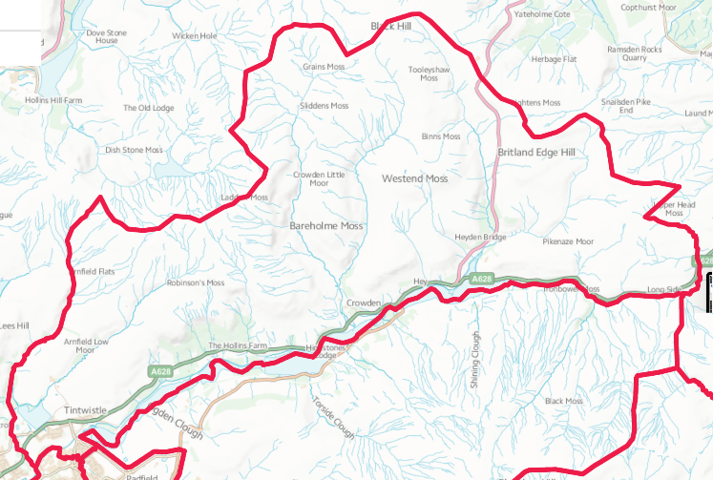
“From Crowden to Brosscroft and everywhere in between.”

