Bridge Mills / Willow Gardens Housing Development
Dear Residents,
I have agreed with the site manager at the Bridge Mills/ Willow Gardens housing development that he will keep us updated as to the expected schedule of works on site each week so that we know what to expect and hopefully disruption can be minimised.The expected works for week commencing the 14th October are:
- Services continue to be installed and connections within the footpath at the main entrance are to be made (Barratts).
- Foundations for plots continue to be constructed (MKC)
- Stoning up of further development roads and plots (Urban Regen)
- Stoning up of Barratts compound (Urban Regen)
- The traffic management at the front entrance will continue this week until all services have been positively connected.
As ever, if you do have concerns or issues about the works then don't hesitate to get in touch with either myself or one of your Parish Councillors.
Kind regards
Rob
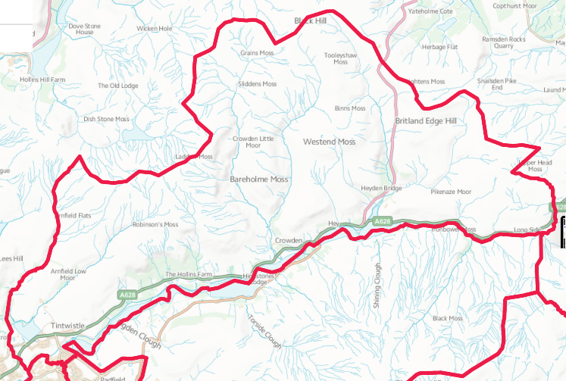
“From Crowden to Brosscroft and everywhere in between.”

