Bridge Mills / Willow Gardens Housing Development
Dear Residents,
I have agreed with the site manager at the Bridge Mills/ Willow Gardens housing development that he will keep us updated as to the expected schedule of works on site each week so that we know what to expect and hopefully disruption can be minimised.The expected works for week commencing the 21st October are:
- Urban Regen – removing temporary offices, preparing the Barratts site compound and surveying site conditions.

- MKC – Continuing installation of foundations to new plots.

Kind regards
Rob
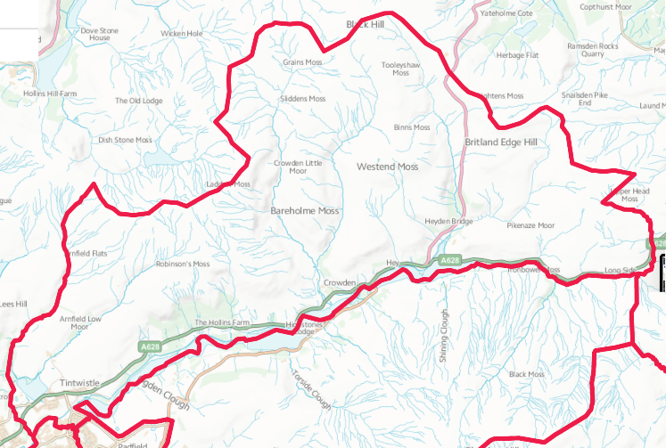
“From Crowden to Brosscroft and everywhere in between.”

