Bridge Mills / Willow Gardens Housing Development
Dear Residents,
I have agreed with the site manager at the Bridge Mills/ Willow Gardens housing development that he will keep us updated as to the expected schedule of works on site each week so that we know what to expect and hopefully disruption can be minimised.The expected works for week commencing the 28th October are:

- MKC Groundworks to continue to install plot foundations.
- Low loader vehicles will be coming to site to remove the remainder of Urban Regen plant and machinery.
- Temporary traffic lights will be removed from New Road today (28/10/19), but will return at some point week commencing 4/11/19 (next week) in order to carry out the electric and water connections to the existing mains within the carriageway. The reason for so many disruptions to New Road is that the existing service mains were not positioned as per historical records indicated and therefore has required more exploratory work to find them than anticipated.
- Argyle NW will commence installation of the next phase of roads within site towards the end of this week which will also mean arrival of several items of plant and machinery
Kind regards
Rob

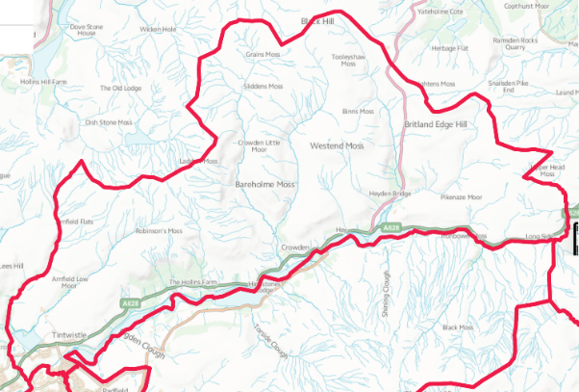
“From Crowden to Brosscroft and everywhere in between.”

