Bridge Mills / Willow Gardens Housing Development
Dear Residents,
I have agreed with the site manager at the Bridge Mills/ Willow Gardens housing development that he will keep us updated as to the expected schedule of works on site each week so that we know what to expect and hopefully disruption can be minimised.The expected works for week commencing the 11th November are:
- Utility connections due to start on New Road on Wednesday 13th November which will involve temporary traffic light systems being in place adjacent to the bridge.
- Mortar silo deliveries to site Thursday, Friday and Monday.
- MKC continue foundation installation.
- Argyle NW have commenced installation of the next phase of roads and sewers on site.
- Bulk deliveries of building materials how now started arriving on site and will now be continuous for the duration of the project.

Kind regards
Rob

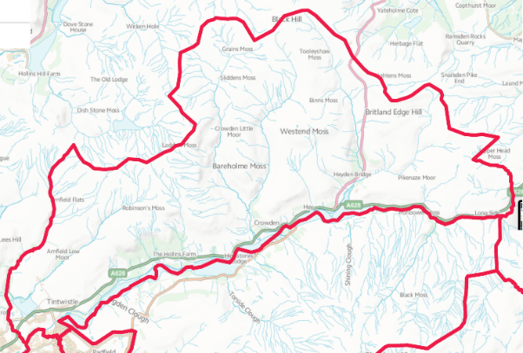
“From Crowden to Brosscroft and everywhere in between.”

