DERBYSHIRE COUNTY COUNCIL
FOOTPATH CLOSURE EXTENSION
PUBLIC FOOTPATH NO.11
TINTWISTLE AND PUBLIC FOOTPATH NO.51 CHARLESWORTH

NOTICE IS HEREBY GIVEN that the Order made by Derbyshire County Council on 13th June 2019 under Section 14 of The Road Traffic Regulation Act 1984 (as amended) the effect of which was to close Public Footpath No.11 Tintwistle and Public Footpath No.51 Charlesworth from the beginning of the footbridge over the river Ethrow to the end of the track over the dam has been further continued. The alternative route will be from the south follow footpath No.51 south west to its junction with footpath No.52. Follow footpath No.61 north and continue over the parish border as footpath No.12. Follow the track off the footpath No.12 west to footpath No.11. Vice Versa from the north.
The footpath will be closed until 01st March 2020 or until the works are completed, whichever is the sooner, to allow for public safety during grouting works on the crest of the embankment.

Derbyshire County Council apologise for any inconvenience caused during the duration of the closure. Any member of the public requiring further information should ring Call Derbyshire on 01629 533190.
MIKE ASHWORTH, EXECUTIVE DIRECTOR OF ECONOMY, TRANSPORT AND ENVIRONMENT
COUNTY HALL, MATLOCK DE4 3AG

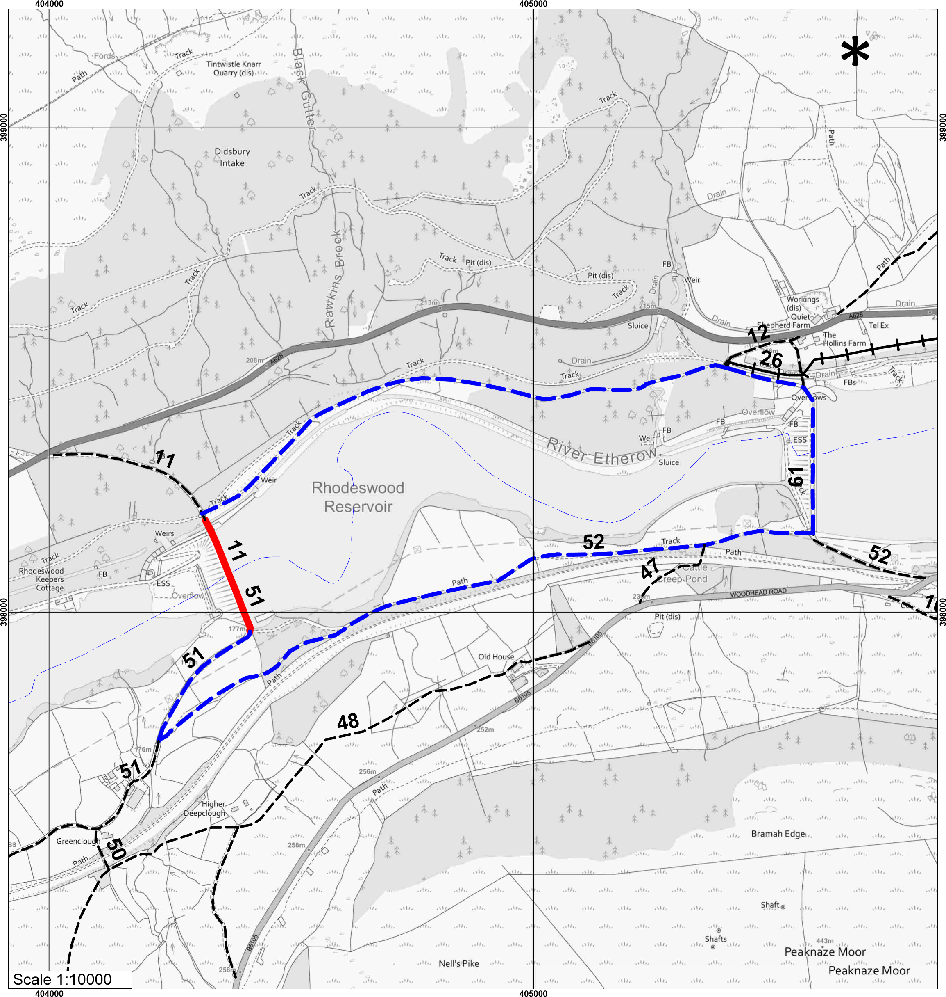
Road Traffic Regulation Act 1984 s14
TEMPORARY CLOSURE
TINTWISTLE FOOTPATH 11 & CHARLESWORTH FOOTPATH 51
PATH  CLOSED  UNAFFECTED  FOOTPATH | ALTERNATIVE ROUTE  UNAFFECTED  BRIDLEWAY |  | 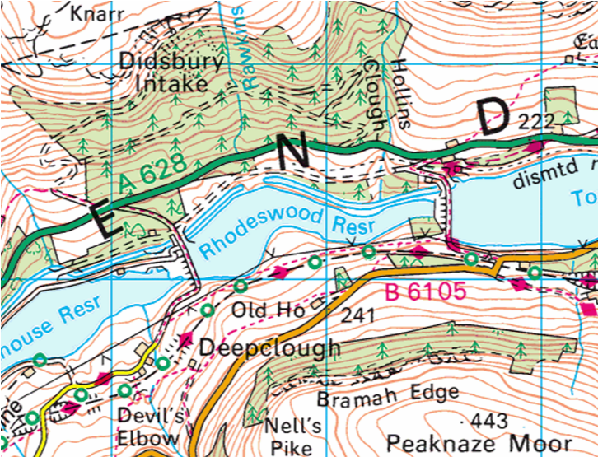
Mike Ashworth
Strategic Director
Economy, Transport & Environment
Derbyshire County Council
Shand House
Dale Road South
Matlock
DE4 3RY
 |  | Produced by Public Rights of Way
 |  | Ref:
© Crown copyright and database rights [2018]. Ordnance Survey [100023251].
You are not permitted to copy, sub-licence, distribute or sell any of this data to third parties in any form.

