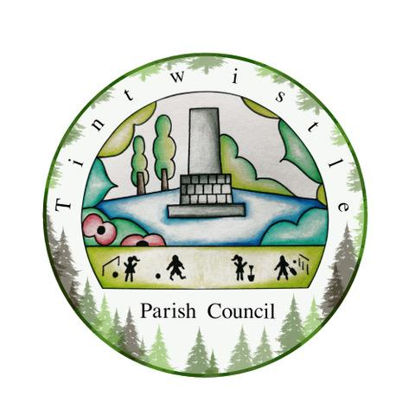

Council Offices
Sexton Street Portacabin
New Road
Tintwistle
Glossop
Derbyshire
SK13 1JN

09th December 2020

AGENDA

Dear Councillor,

You are hereby invited to attend a meeting of Tintwistle Parish Council to be held remotely on Monday 14th December 2020 at 7.00pm to discuss the following business:-

Yours sincerely

Clerk and Financial Officer to the Council

Item No.

- To receive apologies for absence.

- To receive a report from the Borough Councillor (if any).

- To sign the minutes of a meeting of this Council held on Monday 16th November 2020.
Follow up summary.

- To receive correspondence as follows:-
- Derbyshire County Council
- High Peak Borough Council
- Peak District National Park
- Derbyshire Association of Local Councils
- Local/residents – emails/requests for discussion

- Accounts for payments and receipts.

- Health and Safety update.
Anti-Slip Matting and Sanitary Disposal Unit – Approval. (Cllr Owens)

- Expenditure Approval.
Rotary Club Plaque.
Feasibility Study for the MUGA. (Cllr Stevenson/Cllr Crossland)
Planning Consultation expenses - £2,600 plus VAT.

- Approval of the Business Plan outcomes 19/20. (Cllr Stevenson)

- A57 Links Road Consultation response.

- The Quarry update. (Cllr Stevenson/Cllr Owens)

- Future Meetings – Precept meeting in January to be extended to include discussion on Community Centre Project decisions or for two separate meetings to be held to cover both – Discuss.

- Date of next meeting

