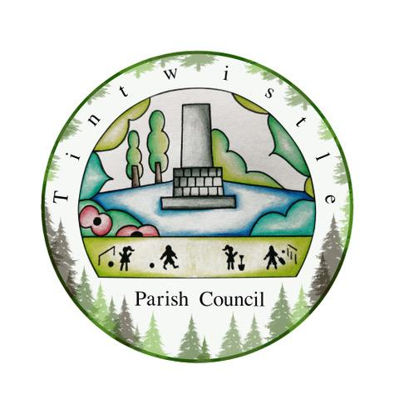

Council Offices
Sexton Street Portacabin
New Road
Tintwistle
Glossop
Derbyshire
SK13 1JN

20th January 2021

AGENDA

Dear Councillor,

You are hereby invited to attend a meeting of Tintwistle Parish Council to be held remotely on Monday 25th January 2021 at 7.00pm to discuss the following business:-

Yours sincerely

Clerk and Financial Officer to the Council

- To receive apologies.

- To discuss the Precept for 2021/2022.
To be included in discussions, quotes for the defibrillator. (Cllr Owens)

- Discussions on the Community Centre Project and approval of report and for Clerk to sign contract/letter and return. (Cllr Stevenson)

- To discuss the bus shelter accessibility improvement proposals.

- Update on results of successful PCCF applicants. (Cllr Stevenson)

- Date of next meeting.

