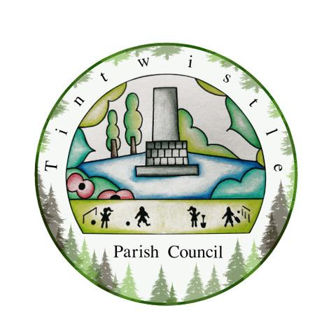

Council Offices
Sexton Street Portacabin
New Road
Tintwistle
Glossop
Derbyshire
SK13 1JN

10th March 2021

AGENDA

Dear Councillor,

You are hereby invited to attend a meeting of Tintwistle Parish Council to be held remotely on Monday 15th March 2021 at 7.00pm to discuss the following business:-

Yours sincerely

Clerk and Financial Officer to the Council

Item No.

- Robert Largan – MP High Peak.

- To receive apologies for absence.

- To receive a report from the Borough Councillor (if any).

- To sign the minutes of a meeting of this Council held on Monday 15th February 2021.
Follow up summary.

- To receive correspondence as follows:-
- Derbyshire County Council
- High Peak Borough Council
- Peak District National Park
- Derbyshire Association of Local Councils
- Local/residents – emails/requests for discussion

- Accounts for payments and receipts.
Payment approval for Social Media training session 17th March with DALC.
Payment approval for What3Words signs for defibrillator. (AD)

- Tintwistle Community Centre update and report. (MS)

- Allotments sub-committee update and minutes. (PJ)

- Issues regarding state of drains, lights and roadway at Woolley Mill Lane to be raised. (TO)

- Draft Business Plan 2021 – 2023 and report for suggestions and discussion. (MS)

- To agree to draft a co-option policy. (MS)

- Approval and arrangements for meeting with Highways England regarding road safety concerns on the A628 at Tintwistle. (MS)

- Approval for policies at future meetings. (MS)

- To give notice for closed session on HR matters. (MS)

- Dates for Annual Council meeting and Annual Parish meeting. (BL)

- Date of Next meeting.

