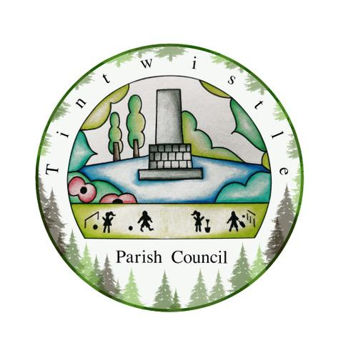

Council Offices
Sexton Street Portacabin
New Road
Tintwistle
Glossop
Derbyshire
SK13 1JN

10th February 2021

AGENDA

Dear Councillor,

You are hereby invited to attend a meeting of Tintwistle Parish Council to be held remotely on Monday 15th February 2021 at 7.00pm to discuss the following business:-

Yours sincerely

Clerk and Financial Officer to the Council

Item No.

- To receive apologies for absence.

- To receive a report from the Borough Councillor (if any).

- To sign the minutes of a meeting of this Council held on Monday 14th December 2020.
Follow up summary.

- To receive correspondence as follows:-
- Derbyshire County Council
- High Peak Borough Council
- Peak District National Park
- Derbyshire Association of Local Councils
- Local/residents – emails/requests for discussion

- Accounts for payments and receipts.
Alliance Environmental agreement – approval.
Extra dog waste bin – approval.
Bus shelter maintenance agreement – approval.

- Community Centre update and report. (Cllr Stevenson)

- Allotments update. (Cllr Jenner)

- TPC Community Fund outcomes and report. (Cllr Stevenson)

- Village Green Status.
Re: Application to register land know as Sexton Street recreational grounds and bowling green, Tintwistle. Discussion and decision, to apply or not. (Cllr Jenner)

- To further on-line banking – Discussion and decision. (Clerk)

- Holybank Quarry and report.
To propose that Tintwistle Parish Council joins the Trust’s Wild Peak Network.
(Cllr Stevenson)

- Date of next meeting.

