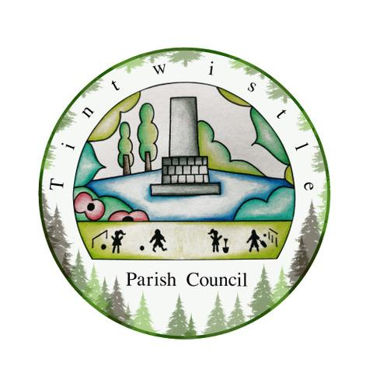

Council Offices
Sexton Street Portacabin
New Road
Tintwistle
Glossop
Derbyshire
SK13 1JN

14th April 2021

AGENDA

Dear Councillor,

You are hereby invited to attend a meeting of Tintwistle Parish Council to be held remotely on Monday 19th April 2021 at 7.00pm to discuss the following business:-

Yours sincerely

Clerk and Financial Officer to the Council

Item No.

- To receive apologies for absence.

- To receive a report from the Borough Councillor (if any).

- To sign the minutes of a meeting of this Council held on Monday 15th March 2021.
Follow up summary.

- To receive correspondence as follows:-
- Derbyshire County Council
- High Peak Borough Council
- Peak District National Park
- Derbyshire Association of Local Councils
- Local/residents – emails/requests for discussion

- Accounts for payments and receipts.
Ground Maintenance Service Legal Agreement – Approval.

- Tintwistle Community Centre update and report. (MS)

- Extraordinary meeting held on 30th March 2021 - Allotments – to approve reports. . (PJ)

- Issues regarding state of drains, lights and roadway at Woolley Mill Lane to be raised. (TO)

- Draft Business Plan 2021 – 2023 and report for suggestions and discussion. (MS)

- Draft co-option procedures and policy approval.

- NHS – QR Code requirement. (AD)

- Date of Next meeting.

