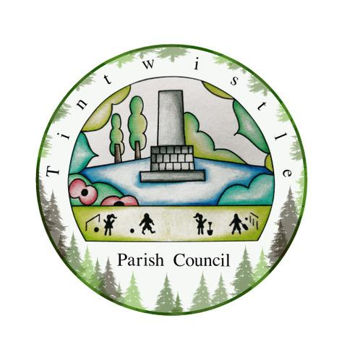

Council Offices
Sexton Street Portacabin
New Road
Tintwistle
Glossop
Derbyshire
SK13 1JN

11th May 2021

AGENDA

Dear Councillor,

You are hereby invited to attend a meeting of Tintwistle Parish Council to be held at these offices on Monday 17th May 2021 at 7.30pm to discuss the following business:-

Yours sincerely

Clerk and Financial Officer to the Council

Item No.

- To receive apologies.

- To receive a report from the Borough Council (if any).

- To sign the minutes of a meeting of this Council held on Monday 19th April 2021.

- To elect a new Chairperson for the year 2021/2022.

- To elect a new Vice-Chairperson for the year 2021/2022.

- To receive disclosures of interest on any matter before the Council, if not already previously disclosed.

- To receive correspondence as follows:-
- Derbyshire County Council
- High Peak Borough Council
- Peak District National Park
- Derbyshire Association of Local Councils

- Accounts for payments and receipts.
Current budget update.

- Allotments –: To approve amendments to reports. (PJ)
: To approve Code of Conduct for allotments. (PJ)
: To report on outcomes of meeting held on Conduit Street allotment site.
(PJ/MS)

- Issues regarding state of drains, lights and roadway at Woolley Mill Lane to be raised. (TO)

- Update on meeting held with Highways England on 29th April 2021. (MS/TO)

- Agreement to resolve to have a Tintwistle Parish Council facebook page. (MS)

- Dates of future Parish Council meetings.

