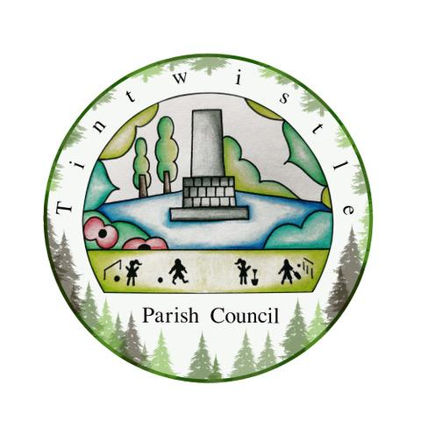

Council Offices
Sexton Street Portacabin
New Road
Tintwistle
Glossop
Derbyshire
SK13 1JN

15th June 2021

AGENDA

Dear Councillor,

You are hereby invited to attend a meeting of Tintwistle Parish Council to be held on Monday 21st June 2021 at 7.30pm to discuss the following business:-

Yours sincerely

Clerk and Financial Officer to the Council

Item No.

- To receive apologies for absence.

- To receive a report from the Borough Councillor (if any).

- To sign the minutes of a meeting of this Council held on Monday 17th May 2021.
Follow up summary.

- To receive correspondence as follows:-
- Derbyshire County Council
- High Peak Borough Council
- Peak District National Park
- Derbyshire Association of Local Councils
- Local/residents – emails/requests for discussion

- Accounts for payments and receipts.
AGAR
Architectural Services Contract – JDA Ltd

- To approve the revised Allotment Tenants’ Guidance – Terms and Conditions, Waiting List Policy, Code of Conduct, Application Form. (PJ/MS)

- Tintwistle Community Centre update and report. (MS)

- PCCF – To approve the process for 2021/22 and report. (MS)

- To approve the arrangements for setting up and managing the TPC Facebook and report. (AD/ES)

- Councillors’ Initiative Fund – To approve an application for funding to contribute to the cost of this year’s plants for the Cenotaph and planters in the village and report. (MS)

- To approve the TPC Records Retention Policy and draft LIA. (BL)

- To report and approve the outcomes of the meeting held with High Peak MP Robert Largan on 2nd June 2021. (MS)

- Date of next meeting.

Please note Parish Council meetings:

Monday 19th July 2021 7.30pm
Monday 20th September 2021 7.30pm
Monday 18th October 2021 7.30pm
Monday 15th November 2021 7.30pm

