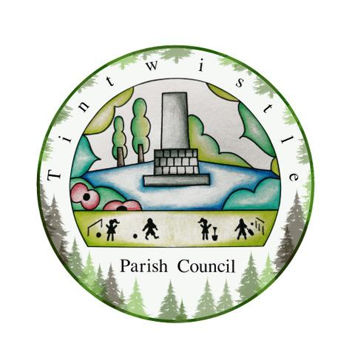

Council Offices
Sexton Street
New Road
Tintwistle
Glossop
Derbyshire
SK13 1JN

21st July 2021

AGENDA

Dear Councillor,

You are hereby invited to attend a meeting of Tintwistle Parish Council to be held on Wednesday 28th July 2021 at 7.30pm to discuss the following business:-

Yours sincerely

Clerk and Financial Officer to the Council

Item No.

- To receive apologies for absence.

- To receive a report from the Borough Councillor (if any).

- To sign the minutes of a meeting of this Council held on Monday 21st June 2021.
Follow up summary.

- To receive correspondence as follows:-
- Derbyshire County Council
- High Peak Borough Council
- Peak District National Park
- Derbyshire Association of Local Councils
- Local/residents – emails/requests for discussion

- Accounts for payments and receipts.

- Tintwistle Community Centre update and Project Team Report. (MS)

- Allotment tenants’ pack – Terms and Conditions, Code of Conduct, Waiting List Policy, Application Form - for approval for distribution in September. (PJ)

- To approve the arrangements for setting up and managing the TPC Facebook and Social Media Policy report. (AD/ES)

- Assets of Community Value – Proposal to apply for The Bull’s Head Public House. (MS)

- Health and Safety Committee Report – Plans for the Annual Review. (MS)

- Approval for two signs for the driveway from Old Road up to the Arnfield Allotments and Cabin. (AD)

- Date of next meeting.

Please note Parish Council meetings:

Monday 20th September 2021
Monday 18th October 2021
Monday 15th November 2021

