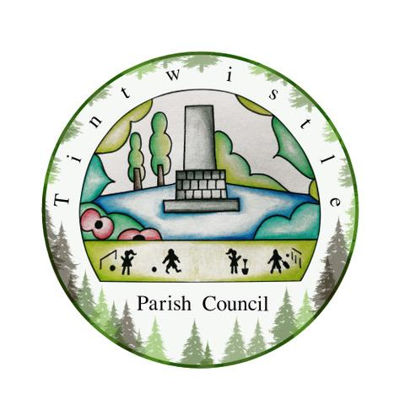

Council Offices
Sexton Street
New Road
Tintwistle
Glossop
Derbyshire
SK13 1JN

15th September 2021

AGENDA

Dear Councillor,

You are hereby invited to attend a meeting of Tintwistle Parish Council to be held on Monday 20th September 2021 at 7.00pm to discuss the following business:-

Yours sincerely

Clerk and Financial Officer to the Council

Item No.
- Presentation of the prizes for the Tintwistle Village Scarecrow and Village Flower Power competitions – 7.05pm.

- To receive apologies for absence – 7.30pm.

- To receive a report from the Borough Councillor.

- To sign the minutes of a meeting of this Council held on Wednesday 28th July 2021.
Follow up summary.

- To receive correspondence as follows:-
- Derbyshire County Council
- High Peak Borough Council
- Peak District National Park
- Derbyshire Association of Local Councils
- Local/residents – emails/requests for discussion

- Accounts for payments and receipts.

- Tintwistle Community Centre update and draft report. (MS)

- Impact of health changes – briefing. (MS)

- Tintwisle Parish Councils’ response to climate change – group and policy set up. (MS)

- HR Policy. (BL)

- Invite to the Church Christmas Tree event – approval. (MS)

- Date of next meeting.

Please note Parish Council meetings:

Agenda items for the next meeting are required by Monday 11th October 2021.

Monday 18th October 2021 7.30pm
Monday 15th November 2021 7.30pm

