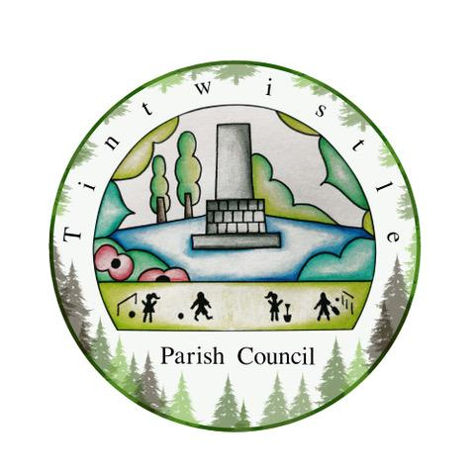

Council Offices
Sexton Street
New Road
Tintwistle
Glossop
Derbyshire
SK13 1JN

27th October 2021

AGENDA

Dear Councillor,

You are hereby invited to attend an extraordinary meeting of Tintwistle Parish Council to be held on Monday 1st November 2021 at 7.30pm to discuss the following business:-

Yours sincerely

Clerk and Financial Officer to the Council

Item No.

- Allotment Committee Inspection report. (PJ)

- Holybank Quarry DWT report – next steps. (MS and TO)

- DCC Response to the Complaints about Tintwistle Footpath 2 (the cinder path). (MS)

- Request for Trees on West Street – Decision: Approval of proposed initial response. (MS)

- Climate Change Action Plan – Decision: Approval of initial steps. (MS)

- Tintwistle Christmas Market – Confirmation for the £200 marquee payment. (ES)

