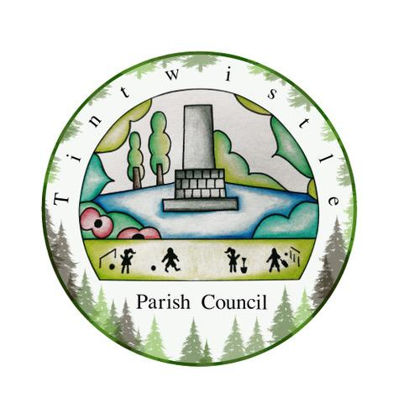

Council Offices
Sexton Street
New Road
Tintwistle
Glossop
Derbyshire
SK13 1JN

13th October 2021

AGENDA

Dear Councillor,

You are hereby invited to attend a meeting of Tintwistle Parish Council to be held on Monday 18th October 2021 at 7.00pm to discuss the following business:-

Yours sincerely

Clerk and Financial Officer to the Council

Item No.
- Presentation of the prizes for the Tintwistle Village Scarecrow and Village Flower Power competitions – 7.05pm.

- To receive apologies for absence – 7.30pm.

- To receive a report from the Borough Councillor.

- To sign the minutes of a meeting of this Council held on Monday 20th September 2021.
Follow up summary.

- To receive correspondence as follows:-
- Derbyshire County Council
- High Peak Borough Council
- Peak District National Park
- Derbyshire Association of Local Councils
- Local/residents – emails/requests for discussion

- Accounts for payments and receipts.
Response to Cricket Club request for a loan.
Purchase of plants for the Cenotaph for Remembrance Sunday.

- Tintwistle Community Centre report. (MS)

- Request for an Extraordinary meeting, to include Cllr Becki Woods.

- Parish Council Community Fund – Outcomes of Funding Round 2. (MS)

- HR Policy. (BL)

- Health and Safety Policy – next steps. (BL)

- Arrangements for Remembrance Sunday. (SG)

- Date of next meeting.

Please note Parish Council meetings:

Agenda items for the next meeting are required by Monday 8th November 2021.

Monday 15th November 2021 7.30pm

