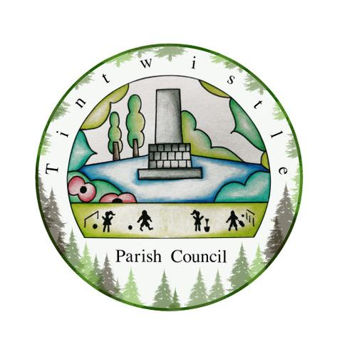

Council Offices
Sexton Street
New Road
Tintwistle
Glossop
Derbyshire
SK13 1JN

10th November 2021

AGENDA

Dear Councillor,

You are hereby invited to attend a meeting of Tintwistle Parish Council to be held on Monday 15th November 2021 at 7.30pm to discuss the following business:-

Yours sincerely

Clerk and Financial Officer to the Council

Item No.

- To receive apologies for absence.

- To receive a report from the Borough Councillor.

- To sign the minutes of a meeting of this Council held on Monday 18th October 2021.
Follow up summary.

- To receive correspondence as follows:-
- Derbyshire County Council
- High Peak Borough Council
- Peak District National Park
- Derbyshire Association of Local Councils
- Local/residents – emails/requests for discussion

- Accounts for payments and receipts.
Application for a TEN licence and fee approval. (ES)
Approval for purchase of display boards for the fund raising campaign. (MS)

- Tintwistle Community Centre report. (MS)

- Report from the Allotments Committee. (PJ)

- HR Policy. (BL)

- Outcomes of the TPC finance meeting. (MS/AD/BL)
Current Budget to date. (BL)

- Tintwistle Footpath 2 – update. (MS)

- Planting Trees on West Drive – update. (MS)

- Date of next meeting.

