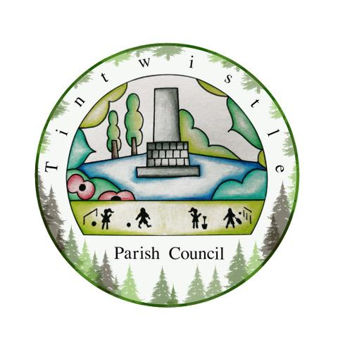

Council Offices
Sexton Street
New Road
Tintwistle
Glossop
Derbyshire
SK13 1JN

16th February 2022

AGENDA

Dear Councillor,

You are hereby invited to attend a meeting of Tintwistle Parish Council to be held on Monday 21st February 2022 at 7.30pm to discuss the following business:-

Yours sincerely

Clerk and Financial Officer to the Council

Item No.

- To receive apologies for absence.

- To receive a report from the Borough Councillor.

- To sign the minutes of a meeting of this Council held on Monday 13th December 2021.
Follow up summary.

- To receive correspondence as follows:-
- Derbyshire County Council
- High Peak Borough Council
- Peak District National Park
- Derbyshire Association of Local Councils
- Local/residents – emails/requests for discussion

- Accounts for payments and receipts.
Approval for £50 deposit for marquees for 5th June 2022 Jubilee market. (ES)

- Tintwistle Community Centre Report. (MS)

- Update on Climate Emergency Plan. (MS)
- Parish Council Community Fund Report. (MS)

- Holybank Quarry Activities - Update. (MS) (TO)

- Tintwistle Footpath 2 – Update. (MS)

- West Drive Trees Initiative. (MS)

- Plans for the Queen’s Platinum Jubilee Celebrations. (MS)

- Meeting with Robert Largan and United Utilities. (MS)

- Update on Recruitment Arrangements for the Clerk/RFO post. (MS)

- Date of next meeting.

