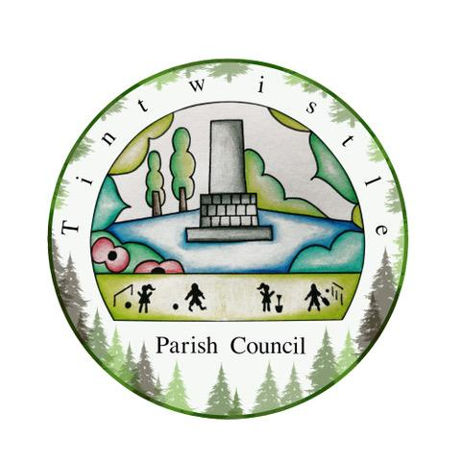

Council Offices
Sexton Street
New Road
Tintwistle
Glossop
Derbyshire
SK13 1JN

16th March 2022

AGENDA

Dear Councillor,

You are hereby invited to attend a meeting of Tintwistle Parish Council to be held on Monday 21st March 2022 at 7.30pm to discuss the following business:-

Yours sincerely

Clerk and Financial Officer to the Council

Item No.

- To receive apologies for absence.

- To receive a report from the Borough Councillor.

- To sign the minutes of a meeting of this Council held on Monday 21st February 2022.
Follow up summary.

- To receive correspondence as follows:-
- Derbyshire County Council
- High Peak Borough Council
- Peak District National Park
- Derbyshire Association of Local Councils
- Local/residents – emails/requests for discussion

- Accounts for payments and receipts.
Approval – School House sign £75.00
DWT Opportunity Mapping £385.00
Retrospective approval - Second advert for Parish Clerk/RFO £180.00

- Tintwistle Community Centre Report 15. (MS)

- Photocopier Replacement Proposal. (AD)

- Vicarage Land Proposal. (SG)

- Update on Holybank Quarry Developments. (MS)

- Proposal for Car Boot Sale – Proceeds to Ukraine Appeal. (AD)

- Arrangements for Annual Council and Parish Council Meetings. (MS/BL)

- Recruitment Update. (MS)

- TPC Business Plan Review 22. (MS)

- Update on Jubilee Celebrations. (MS/SG/ES)

- Date of next meeting.

