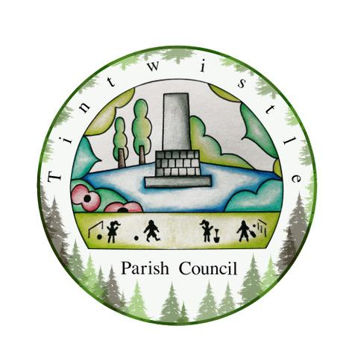

TINTWISTLE PARISH COUNCIL AND THE BOWLING CLUB

MINUTES OF THE MEETING HELD ON 26 APRIL 2022 3.00 -4.00pm

Present: Warwick Coulthard and Frank Thomason, Bowling Club;
Cllr Marianne Stevenson, Tintwistle Parish Council

- Purpose of the Meeting
To agree the next steps in planning for facilities for the Bowling Club in the context of the Parish Council’s plans to build a new Community Centre on the current site on Sexton Street.

- The Current Situation
The Bowling Club has been in negotiation with HPBC Planning department for some time with a view to installing a portacabin on the lower part of the field behind the Parish Council building. The Club was prepared to secure a grant for this installation. The Planning Officer has now advised that a portacabin can only be in situ for a maximum of 3 years. Any permanent building needs to comply with conservation standards. The cost of such a building is estimated to be between £40k and £50k. The Bowling Club needs a permanent building. Without facilities for toilets, refreshments and storage, the Bowling Club cannot legally function.
Tintwistle Parish Council is shortly going to submit their planning application for a new Community Centre building on the current site. The design of the building is required to meet conservation standards. The interior layout can be changed after planning permission has been granted.
The Bowling Club has been running for over 80 years. It is a Crown Green Club and as such is not able to secure ‘Flat’ Green national organisation funds. The Tintwistle Club does not have substantial reserves so securing a grant will be essential if new, free-standing facilities are to be created.
Records demonstrate that the Bowling Club used to have a lease agreement with HPBC. This entailed the Bowling Club making an annual payment to HPBC based on a standard financial contribution per member. This agreement was terminated at some unrecorded point and no financial contribution for the use of the Parish Council facilities by the Bowling Club has been made for around ten or more years. This includes a dedicated room. Neither was an agreement drawn up when the Parish Council purchased the Sexton Street land. Parish Councillors have stated that this arrangement is not tenable, given that no other sports club in the village receives free gratis land and facilities for their use.

- The Way Forward
The meeting discussed several ways forward:
- Cllr Marianne Stevenson stated that it was essential that a lease agreement is drawn up between the Parish Council and the Bowling Club. This is needed for any grant funding application. Warwick Coulthard tabled a draft for the Parish Council.
- The Parish Council needs to liaise with the Bowling Club on how storage facilities and meeting space can be included in the Community Centre’s interior building design.
- The necessity for the Bowling Club facilities to be included could be a useful lever as the Parish Council seeks to secure funding.
- The Bowling Club must contribute funding towards the creation of the new build. This needs to be discussed further.

- Next Steps
- Investigate grants for a free-standing building that meets conservation standards and inform the Community Centre Project Group via Cllr Marianne Stevenson (Warwick Coulthard)
- Finalise a lease agreement between Tintwistle Parish Council and the Bowling Club, a draft to be presented to Councillors at the Parish Council May meeting (Cllr Marianne Stevenson)

