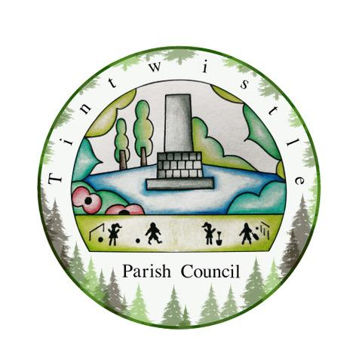

Council Offices
Sexton Street Portacabin
New Road
Tintwistle
Glossop
Derbyshire
SK13 1JN

19th January 2022

AGENDA

Dear Councillor,

You are hereby invited to attend a meeting of Tintwistle Parish Council to be held on Monday 24th January 2022 at 7.30pm to discuss the following business:-

Yours sincerely

Clerk and Financial Officer to the Council

- To receive apologies.

- To discuss the Precept for 2022/2023.

- To agree on the procedures and way forward for the recruitment of a Parish Clerk/RFO.

- Request for the market profit funds to be transferred to the new community centre bank account.

- Date of next meeting.

