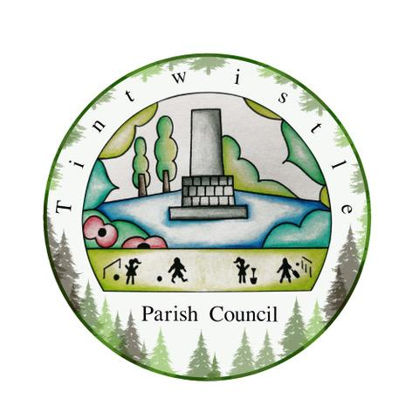

Tintwistle Parish Council
Sexton Street, Tintwistle, SK13 1JN
https://tintwistleparishcouncil.org.uk

AGENDA 11th November 2022

Dear Tintwistle Community Centre Committee,
You are hereby summoned to attend the meeting of Tintwistle Parish Council to be held on Wednesday 16th November 2022 at 6pm at the Council’s office.

Charlotte Strickland
Charlotte Strickland, Clerk to the Council
tpcounciloffices@aol.com

AGENDA (MEMBERS OF THE PUBLIC AND PRESS ARE WELCOME TO ATTEND)

- To receive apologies for absence
- Declarations of interests
- Public participation Upto 15 minutes will be made available for members of the public to raise matters relevant to the business of the Parish Council.
- Terms of Reference and Membership To note the ToR and Membership.
- TCC Fundraising To discuss the next steps.
- National Lottery To discuss the latest guidance.
- Public Works Loan To discuss the latest guidance.
- Bowling Club Lease To confirm the initial draft of the license arrangements.
- Planning Permission outcomes and links with JDA To receive an update on the planning application.
- Date of Next Meeting

