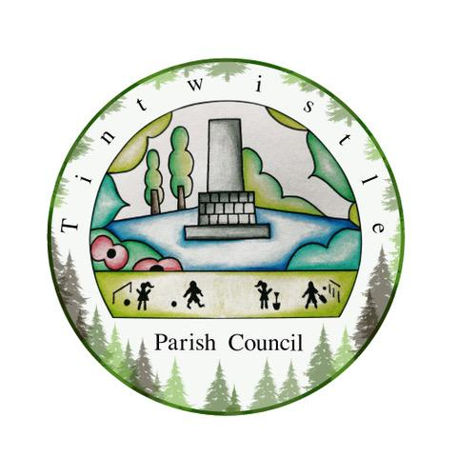
TINTWISTLE PARISH COUNCIL
PARISH COUNCIL COMMUNITY FUND
APPLICATION FORM 2022/23

PLEASE NOTE THERE IS A SHORT TIME SCALE FOR THIS LAST TRANCHE OF PCCF FUNDING

Opening Date for Applications: Monday 6th February 2023
Closing Date for Applications: Monday 13th February 2023 5pm
Total Funding that can be applied for: £100.00
Project Closure Date: 31st March 2023

Name of your Group
Please put an X in this box to confirm you are a formally constituted group *

*Your group must be formally constituted or in the process of setting this up. This means you must have a bank account with at least two independent signatories as well as a governing document and a list of governing members and a set of rules
Name of Project
Contact Name
Telephone Number
Email Address
Contact Address for Correspondence
Describe briefly what your Group does:

Describe the activity you wish to receive funding for – what you will do, how you will do it and what you will be spending funding on:
What will be the benefit of this funding:

Amount of Funding Requested:
If you are applying for funding which involves working with children or vulnerable adults, please put a X to confirm you have the following in place:

Safeguarding Policy
DBS Checks

Are there any TPC Councillors connected to your organisation as a Committee Member? | (YES or NO)
If YES, please write the name of the Councillor(s)

FINISHING YOUR APPLICATION
On behalf of the organisation, I confirm that the information in this application is correct, and the organisation is not established or conducted for profit.
In the event of funding being awarded I also confirm that the organisation will abide by the conditions of funding below and will inform the Parish Council of any change in circumstances that would affect this application.

Signed
Date
Position in the Organisation

Sending us your application:
- By email: Save your electronic application form, attach it to an email and send it to: tpcounciloffices@aol.com
- By post: Clerk to the Council, Tintwistle Parish Council, Sexton Street, Tintwistle, Derbyshire SK13 1JN

FUNDING CONDITIONS
Tintwistle Parish Council retains the right to reclaim, at any time, all or part of the awarded money and any asset purchased if it is not spent or used for the purpose for which it was awarded. The organisation must inform the Parish Council immediately if it is unable to accept or comply with any of the following conditions:
- The group applying for funding is properly constituted. A copy of the signed constitution/governing document is to be provided if requested.
- Funding from the Parish Council Community Fund must be used for the specific purpose for which it is granted.
- No asset purchased using the grant will be sold or transferred without agreement from Tintwistle Parish Council.
- The funding support will be recognised as a ‘one off’ award and does not imply that Tintwistle Parish Council is committed to any future funding. The award must be spent within the period stated on the application form or otherwise returned to the Parish Council.
- The organisation will provide receipted invoices if requested by the Parish Council where awarded money is used to purchase goods/services. The award will be recorded in the organisation’s accounts/bank statement or inventory which will be made available for inspection by the Parish Council. The organisation agrees to cooperate in any monitoring of the benefits and use of the funding.
- Tintwistle Parish Council will not be held responsible for any action of the organisation or anyone acting on their behalf.
- The organisation will recognise and support the Parish Council’s commitment to safeguarding the environment, equal opportunities and diversity and will endeavour to ensure that the project does not have a detrimental impact.

