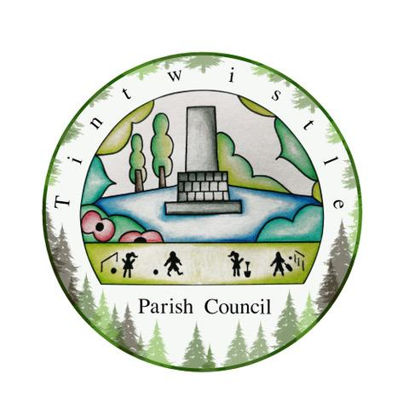

Tintwistle Parish Council
Sexton Street, Tintwistle, SK13 1JN
https://tintwistleparishcouncil.org.uk

13 January 2022

AGENDA

Dear Electors and members of the public,
You are hereby summoned to attend the Tintwistle Parish Meeting to be held on Monday 23 January 2023 at 6.30pm at Tintwistle Primary School, South Close, Tintwistle.

The meeting will be open to the public during the proceedings unless the parish meeting by resolution otherwise direct.

Charlotte Strickland
Charlotte Strickland, Clerk to the Council
tpcounciloffices@aol.com

AGENDA (MEMBERS OF THE PUBLIC AND PRESS ARE WELCOME TO ATTEND)

- To receive apologies for absence

- KCS Development presentation To receive a presentation from Richard Morton from KCS Developments regarding local development opportunities with an opportunity for attendees to ask any questions.

- Public Participation Session To discuss any issues raised from the floor.

