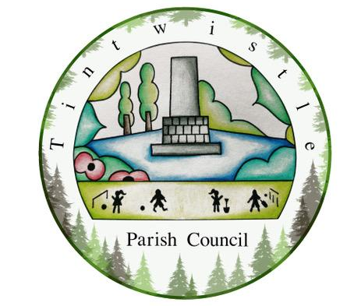
15th May 2023

Dear Councillors,
You are hereby summoned to attend the meeting of Tintwistle Parish Council to be held on Monday 22nd May 2023 at 7.30pm at the Tintwistle Primary School, South Close, Tintwistle.
Charlotte Strickland
Charlotte Strickland, Clerk to the Council
tpcounciloffices@aol.com

AGENDA

- Election of the Chair of the Council for the year 2023/24
- Election of the Vice-Chair of the Council for the year 2023/24
- To receive apologies for absence
- Declarations of Acceptance of Office
- Declarations of Members Interests
- Committees
  - To review Committee structures and to appoint members to serve on the following Committees: i) Allotments Committee ii) Tintwistle Community Centre Committee and iii) Health and Safety Committee
  - To review and consider re-adopting the existing Committee Terms of Reference for each Committee (with agreement that these can be amended during the year).
- Council Policies and Documents
  - To review and consider re-adopting: i) Standing Orders ii) Financial Regulations iii) Code of Conduct
  - To consider a schedule for the review of the following Council polices:

Standing Orders | Financial Regulations
Risk Assessment | Health and Safety
Document and Record Retention | Complaints procedure
Code of Conduct | Co-Options
Assets Register | Publication Scheme
Information & Data Protection Policy | Disciplinary and Grievances
Staff Sickness and Absence | Equality and Diversity
Dignity at Work | Key holder

- Parish Council Community Fund Working Group
  - To discuss the continuation of the Community Fund for the year 23/24
  - To appoint Councillors to the PCCF Working Group
- Contractors Review To review the Parish Council’s use of contractors for: i) Cleaning of the Office building ii) Outdoor maintenance iii) Gardening maintenance iv) Litter bin emptying
- Finance & Accounts Procedures Review
- To approve the removal of signatories from the Council’s Unity Trust Bank Account for those Councillors who are no longer serving on the Council
- To agree at least five signatories of the current Council for the Council’s Unity Trust Bank Account
- To approve BACS as a payment method
- To approve the use of direct debit to pay the following: Utility Warehouse (utilities) and Lynbrook (printing) and to approve setting up a direct debit mandate with WaterPlus (water)

Ordinary Monthly Business
- Public participation Up to 15 minutes will be made available for members of the public to raise matters relevant to the business of the Parish Council.
- To approve the minutes of the April Council meeting
- To receive reports from Borough and/or County Councillors
- DALC Newsletter To discuss interest points from the May Newsletter.
- Planning To consider the following planning application: None. (any late applications will be detailed in the minutes.)
- Correspondence:
  - Bonfire issue in Conduit Allotments
  - Overgrown trees on Manchester Road
- Dame Vivienne Westwood Memorial To discuss a request for the removal of a large stone from Holybank Quarry.
- New Community Centre project To receive a project update and to consider the recommendations in the tabled TCCC report:
  - To approve the consultation questions, letter to residents and newsletter information and begin a formal consultation period
  - To consider additional Clerk hours dedicated to creating the PWLB business case
- Peak Parish Parish Election To give delegated authority to the Clerk to respond following consultation with Councillors
- Office Repairs To retrospectively approve urgent repairs to the office building including electrical work and installing a temporary fix to the rotten floor
- Office Stationery To approve the purchase of office supplies
- Finance & Accounts To authorise the tabled accounts for payment.
- To confirm the dates of the next Parish Council meetings as the 3rd Monday in every month at Tintwistle Parish Council Offices, Sexton Street.

