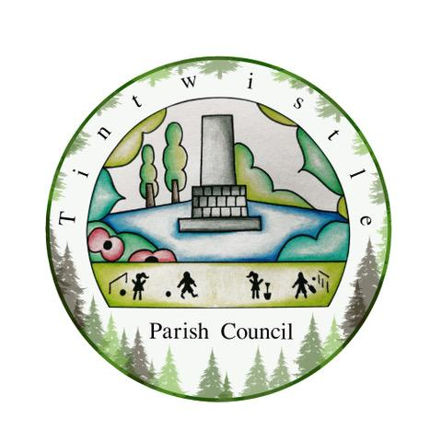

TINTWISTLE PARISH COUNCIL

Publication Scheme -
This publication guide was adopted at the Parish Council meeting on 20/02/2023

The Freedom of Information Act (FOIA) 2000, section 19(1), states:
It shall be the duty of every public authority—
- to adopt and maintain a scheme which relates to the publication of information by the authority and is approved by the Commissioner (in this Act referred to as a “publication scheme”),
- to publish information in accordance with its publication scheme, and
- from time to time to review its publication scheme.
Accordingly, the Parish Council will make the information listed in the scheme below available unless:
- it does not hold the information;
- the information is exempt under one of the FOIA exemptions or Environmental Information Regulations exceptions, or its release is prohibited by another statute;
- the information is readily and publicly available from an external website; the Parish Council will provide a direct link to that information;
- the information is archived, out of date or otherwise inaccessible; or,
- it would be impractical or resource-intensive to prepare the material for routine release.
Publishing datasets for re-use

Public authorities must publish under their publication scheme any dataset they hold that has been requested, together with any updated versions, unless they are satisfied that it is not appropriate to do so. So far as reasonably practicable, they must publish it in an electronic form that is capable of re-use.
If the dataset or any part of it is a relevant copyright work and the public authority is the only owner, the public authority must make it available for re-use under the terms of a specified licence. Datasets in which the Crown owns the copyright or the database rights are not relevant copyright works.
The Datasets Code of Practice recommends that public authorities make datasets available for re-use under the Open Government Licence.
The term ‘dataset’ is defined in section 11(5) of FOIA. The terms ‘relevant copyright work’ and ‘specified licence’ are defined in section 19(8) of FOIA. The ICO has published guidance on the dataset provisions in FOIA. This explains what is meant by “not appropriate” and “capable of re-use”.

Information available from Tintwistle Parish Council under the model publication scheme:

Information to be published | How the information can be obtained | Cost
Class1 - Who we are and what we do  (Organisational information, structures, locations and contacts)  This will be current information only.  N.B. Councils should already be publishing as much information as possible about how they can be contacted. | Website https://tintwistleparishcouncil.org.uk/  Or a Hard Copy - On application to the Parish Clerk | Free  10p per page
Who’s who on the Council and its Committees
Contact details for Parish Clerk and Council members (named contacts where possible with telephone number and email address (if used))
Location of main Council office and accessibility details
Staffing structure
Class 2 – What we spend and how we spend it  (Financial information relating to projected and actual income and expenditure, procurement, contracts and financial audit)  Current and previous financial year as a minimum | Hard Copy - On application to the Parish Clerk | 10p per page
Annual return form and report by auditor
Finalised budget
Precept
Borrowing Approval letter
Financial Standing Orders and Regulations
Grants given and received
List of current contracts awarded and value of contract
Members’ allowances and expenses
Class 3 – What our priorities are and how we are doing  (Strategies and plans, performance indicators, audits, inspections and reviews)  Current and previous year as a minimum | Website https://tintwistleparishcouncil.org.uk/  Or a Hard Copy - On application to the Parish Clerk | Free  10p per page
Parish Plan (current and previous year as a minimum)
Annual Report to Parish or Community Meeting (current and previous year as a minimum)
Quality status
Local charters drawn up in accordance with DCLG guidelines
Class 4 – How we make decisions  (Decision making processes and records of decisions)  Current and previous council year as a minimum | Website https://tintwistleparishcouncil.org.uk/  Or a Hard Copy - On application to the Parish Clerk | Free  10p per page
Timetable of meetings (Council and any committee/sub-committee meetings and parish meetings)
Agendas of meetings (as above)
Minutes of meetings (as above) – n.b. this will exclude information that is properly regarded as private to the meeting.
Reports presented to council meetings – n.b. this will exclude information that is properly regarded as private to the meeting.
Responses to consultation papers
Responses to planning applications
Bye-laws | N/A
Class 5 – Our policies and procedures  (Current written protocols, policies and procedures for delivering our services and responsibilities)  Current information only | Website https://tintwistleparishcouncil.org.uk/  Or a Hard Copy - On application to the Parish Clerk
Policies and procedures for the conduct of council business:

Procedural standing orders
Committee and sub-committee terms of reference
Delegated authority in respect of officers
Code of Conduct
Policy statements

Policies and procedures for the provision of services and about the employment of staff:

Internal instructions to staff and policies relating to the delivery of services
Equality and diversity policy
Health and safety policy
Recruitment policies (including current vacancies)
Policies and procedures for handling requests for information
Complaints procedures (including those covering requests for information and operating the publication scheme)

Information security policy
Records management policies (records retention, destruction and archive)
Data protection policies
Schedule of charges (for the publication of information)
Class 6 – Lists and Registers  Currently maintained lists and registers only | Website https://tintwistleparishcouncil.org.uk/  Or a Hard Copy - On application to the Parish Clerk  (some information below may only be available by inspection) | Free  10p per page
Any publicly available register or list (if any are held this should be publicised; in most circumstances existing access provisions will suffice)
Assets register
Disclosure log (indicating the information that has been provided in response to requests; recommended as good practice, but may not be held by parish councils)
Register of members’ interests
Register of gifts and hospitality
Class 7 – The services we offer  (Information about the services we offer, including leaflets, guidance and newsletters produced for the public and businesses)  Current information only | On application to the Parish Clerk  (some information may only be available by inspection)
Allotments
Community centres and village halls
Parks, playing fields and recreational facilities
Seating, litter bins, clocks, memorials and lighting

Contact details:

Please contact us at: tpcounciloffices@aol.com
Council Offices
Sexton Street
off New Road
Tintwistle, Glossop
SK13 1JN
Phone: 07726 272271

