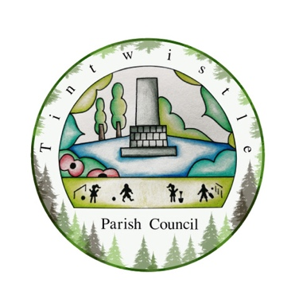

TINTWISTLE PARISH COUNCIL
Flower Power Competition 2023

APPLICATION FORM

Your Name: ___________________
Tel No: ___________________

Address of where the Garden/Flowers will be:

Please let us know if your entering front/rear gardens /both, or where we can find your fabulous floral displays (pots/baskets etc) at the front/rear.
Category/Categories you wish to enter:
/
/
/ /

Cash Prizes for First and Second places…….

Competition to be held on Saturday 15 July 2023
All entries to be received at the Council Offices on Sexton street, by Friday 14th July 2023

