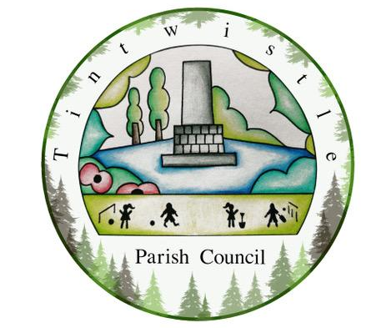
20th June 2023

Dear Councillors,
You are hereby summoned to attend the meeting of Tintwistle Parish Council to be held on Monday 26th June 2023 at 7.30pm at the Parish Council Office.
Charlotte Strickland
Charlotte Strickland, Clerk to the Council
tpcounciloffices@aol.com

AGENDA

- To receive apologies for absence
- Declarations of interests
- Co-Option to Councillor Vacancy To consider Co-Option of any known candidate(s)
- Public participation Upto 15 minutes will be made available for members of the public to raise matters relevant to the business of the Parish Council.
- To approve the minutes of the May Council meeting (circulated)
- To receive reports from Borough and/or County Councillors
- Planning To consider the following planning application: None. (any late applications will be detailed in the minutes.)
- Correspondence:
  - June DALC Newsletter (circulated)
  - Bench restoration at the viewpoint
  - Development Update – KCS and Derbyshire Wildlife Trust
  - Boundaries Consultation (circulated)
  - PCSO update
- Committees/Working Groups
  - To appoint newly co-opted members into existing committees
  - To appoint members to serve on the Health and Safety Committee
  - To appoint a Chair for the PCCF Working Group (Current members: Cllrs Scriven, Dyer, Naz and Vanterpool)
- Review of Council Policies and Documents
  - Key Holder Policy (circulated)
  - Risk Assessment (circulated)
  - To review the Council’s Insurance arrangements
- Contractors Review To approve the updated responsibilities and duties for the role of part-time cleaner or to suggest amendments. (circulated)
- Holybank Quarry Stone Removal To receive an update from PDNP (circulated)
- Full Council Training To approve a full Council training session on 14th August 6-8.30pm at the Council Offices
- Printing Services To discuss and approve offering printing services to the community and to agree either i. a fixed cost per sheet or ii. a percentage uplift of the costs to the Parish Council.
- Community Competitions To approve the annual village Scarecrow and Flower power competitions and agree prizes
- Friends of Holybank Quarry To receive a project update report (to be circulated)
- New Community Centre project To receive a project update, consider the recommendations in the report (to be circulated) and to consider the tabled information to be used in the consultation survey, letter to residents and newsletter.
- Finance & Accounts
  - To receive and note the tabled Annual Internal Audit Report
  - To approve the tabled Annual Governance Statement (Section 1)
  - To approve the tabled Annual Return for the year ended 31 March 2023 (Section 2)
  - To note and approve the commencement date for the exercise of public rights (28th June 2023 – 8th August 2023)
  - To authorise the tabled accounts for payment.
- To confirm the date of the next Parish Council meeting

