**TINTWISTLE PARISH COUNCIL**

**Minutes of Annual Parish Meeting, held on Weds 28th May 2025 at 6.30pm**

**West Drive Football Centre**

Present:

Parish Cllrs M Stevenson (Chair), A Dyer (Vice-Chair), S Grace

Derbyshire County Cllr Jason Isherwood

5 members of the public

Minutes were taken by Parish Clerk T Lewis

**CHAIR’S REPORT**

Cllr Stevenson verbally presented her below report.

*“Welcome to our Annual Parish Meeting and thank you very much for coming along.*

*This is the second Annual Parish Meeting report of your current Parish Council. Apart from my reporting what your Council has achieved over the last 2 years, we would like to hear your comments and suggestions – we shall use them to inform our tasks for the next two years.*

1. *First, I would like to convey my sincere thanks to all the Councillors for the time and hard work they have put in over the last two years to help make Tintwistle and Crowden safe and attractive places to live in. Much of what we Councillors do is hidden - and therefore not always recognised. All Parish Councillors work in a voluntary capacity and receive no payment for the work they do.*
2. *Councillors are reliant on the Clerk of the Council to ensure that we comply with legal and government regulations and maintain our financial records accurately. Until December 2024 Charlotte Strickland was our Clerk. She has been replaced by Tracy Lewis. In the six months Tracy has been with us we have significantly developed and further improved our administration, and I would like to thank Tracy very much for all the work she has put in. Tracy has drawn up a table to illustrate where the Parish Council funding, called the precept, goes. You may have questions about the figures. I would ask you to save them for when I have finished this report or alternatively study them at home and ask myself or Tracy later.*
3. *One of the main objectives of this Council over the last two years has been to secure the funding for a new Community Centre to replace our now very decrepit building. An extremely challenging task at the best of times, but even more so at the time of a pandemic, when funders have been directing their funding towards Covid related projects. Since then, the government have withdrawn the Community Ownership Fund, for which we were preparing an application. We shall continue to look for other capital funding streams and maintain the ‘green hut’ as best we can.*
4. *We have made sure that Crowden residents are kept informed of developments through the Crowden Residents’ Association. The newly formed Trustee group of St James Chapel have done significant fundraising and renovated the Chapel to an extent that it is now used for community events. Indeed, the venue for our last Council meeting was the Chapel. Cllr Meriel Boyd, a Crowden resident, is the Woodhead (Crowden) Ward Councillor and ensures that the ward’s issues are regularly raised at full Council meetings.*
5. *The Allotments Working Party has been chaired by Cllr Allan Dyer for the last 2 years. We have kept to the principle of creating smaller plots, which has enabled more people on the waiting list to receive a plot. Revised Tenant Terms and Conditions, a Waiting List Policy and Code of Conduct are all in place. The Working Party is responsible for regular inspections of allotments and the enforcement of the Terms and Conditions. There has been an improvement in the state of most allotments, and we shall continue to make sure standards are maintained. Our thanks to members of the Working Party for all the work they do.*
6. *We have contacted High Peak Borough Council about the state of the Arnfield Site driveway. As far as we can understand this is their responsibility. We continue to seek a resolution.*
7. *Cllrs Shaun Grace and Emily Scriven have successfully organised the annual Scarecrow Competition, the Garden and Allotment competitions. Cllrs Grace and Buddell have ensured the village has a lit Xmas Tree at the Cenotaph and made sure that Remembrance Sunday is well organised as well as lighting the beacon on VE Day and the Covid Day of Reflection. These occasions are popular with residents and others from outside Tintwistle. Maybe you would like to see more gatherings at this beautiful spot in the village?*
8. *The Parish Council Community Fund was initiated by this Council using monies that were previously allocated to the Chair’s Allowance. £1315 has been allocated in grants to local organisations with a total of 9 applications over the last two years. A decision has been made this year to have one round of applications only, thereby reserving funds for repairs to the ‘green hut’.*
9. *The A628 has continued to be a principal and ongoing issue for the Council. We initiated meetings with National Highways (NH) in 2020, and this has culminated in their decision to create a ‘Village Gateway’ along the A616 and A628 to include Crowden, Tintwistle and Hollingworth. This is a set of traffic calming measures that are designed to slow down the traffic and make the road safer for motorists and pedestrians alike. National Highways have carried out a substantial part of the Gateway features, which includes 3 speed signs in Tintwistle. Residents have reported less speeding through the village. However, it remains a serious issue, and the Council will continue to work with NH to improve conditions and safety.*
10. *Alongside other councils across the country, Tintwistle has drawn up a Climate Change Emergency Action Plan. We are very pleased to have Sara Scott-Rivers support us as our Climate Change Campaign Coordinator. You will have seen her weekly posts on Facebook, which we hope are encouraging residents to make the changes in their lives that are so urgently needed to preserve our planet. Sara succeeded in obtaining Dame Vivienne Westwood’s signature on certificates for our Green Champions, several months before she died. We finally held a celebration of our Green Champions efforts in April this year. The certificates were presented by Ben Westwood. Su Pollard, the actress and Linda Watson, a fashion and textile lecturer and biographer of Vivienne Westwood, both regular visitors to Tintwistle, students of the Arden Theatre and children from Tintwistle CofE Primary School and Gorse Hall Primary, Stalybridge, entertained a large turnout of residents and visitors. We had nothing but compliments on the occasion and many requests to do something like this every year!*
11. *Tintwistle Parish Council owns the Holybank Quarry area, off Old Road. Derbyshire Wildlife Trust have drawn up a 50-year Rewilding Plan for us for the area. Tintwistle Parish Council is the first Parish Council to join the Wild Peak Network. Jane Corkin is our Holybank Quarry Warden. She organises the ‘Friends of the Quarry Group’ who have regular working sessions. They have kept the area litter free, planted some saplings, kept the paths clear, cleared the drainage channel, and created and are maintaining ‘scrapes’ to gather water. Already there have been several quarry visits by groups of children organised by the school. We shall apply for grant funding this year to install information boards about the plants, the wildlife and the fossils that can be seen on some of the rocks. We are curious about who has been creating stone ‘stacks’ which are not acceptable and will lead to the quarry rock faces becoming unstable. Do you know who is responsible?*
12. *The Tintwistle Parish Council Newsletter has continued to be published with 8 publications since April ‘23. We have strived to make the newsletter attractive, interesting, and informative. Do continue to give us ideas for articles.*
13. *The Council needs to work with partners to achieve its objectives and tackle issues as they arise. Our thanks go to High Peak Borough Council and its Tintwistle Councillor Rob Baker, Peak District National Park, United Utilities, Derbyshire Wildlife Trust, National Highways and Derbyshire County Council.*
14. *Finally, our thanks go to all our residents, for the support you give the Parish Council, your feedback and the contacts with our councillors, making us aware of the issues that are important to you”.*

**FINANCIAL UPDATE**

Clerk/Responsible Finance Officer Tracy Lewis talked through the below table:

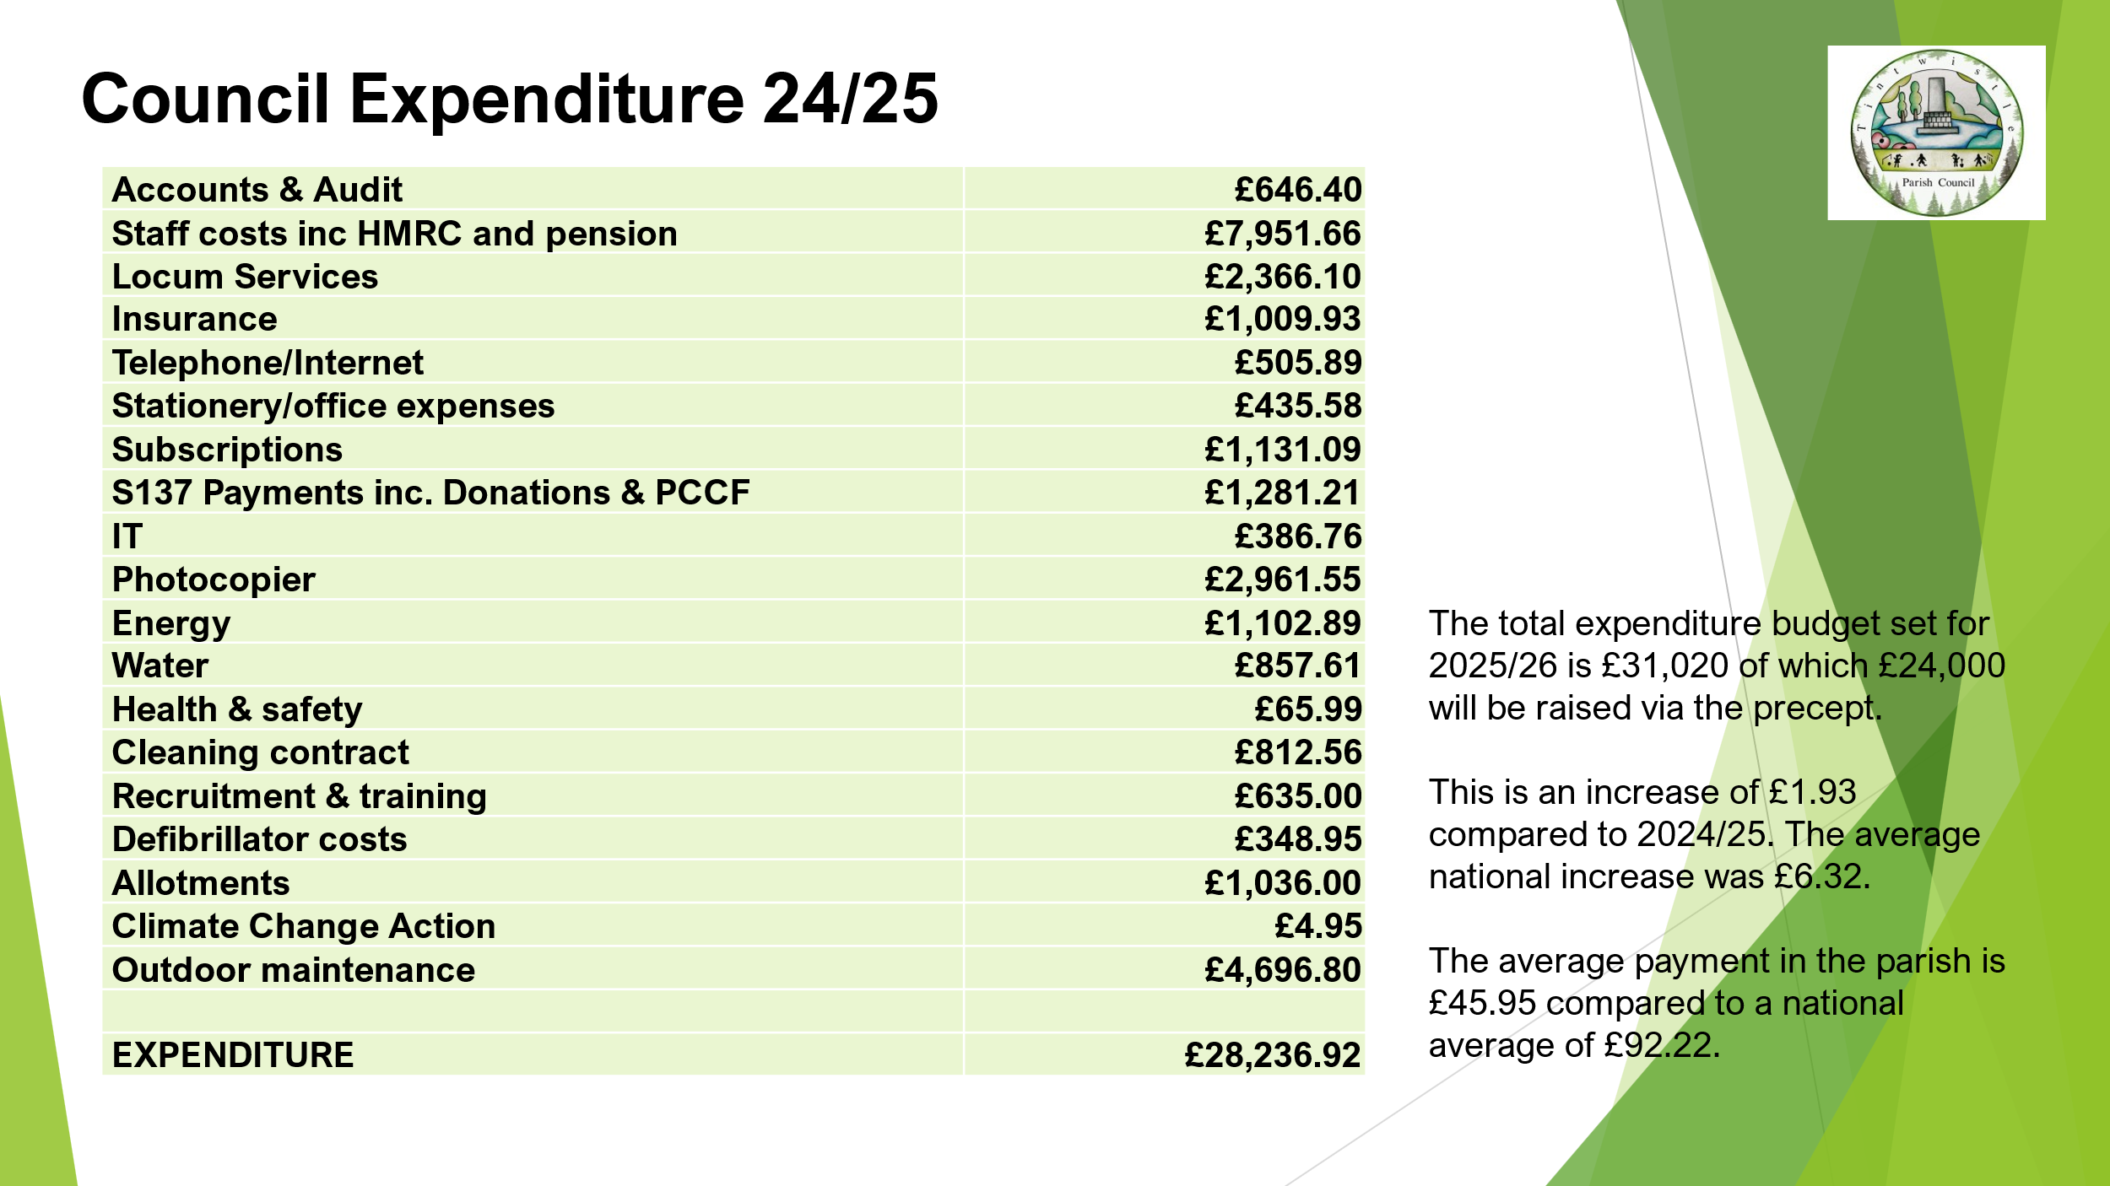

T Lewis also announced that the council’s Unaudited Annual Governance and Accountability Return will shortly be posted and that the public have a right to inspect the council’s financial documents between Tuesday 3rd June and Monday 14th July. Members of the public wishing to exercise their rights are invited to contact the clerk during this period to make arrangements.

**ISSUES RAISED FROM THE FLOOR**

Residents raised and discussed the following points:

* **Events**
  + A resident suggested that some of the funds raised at future council events could be donated to ‘Tintwistle Ladies’ to help their annual Well Dressing preparations.
  + It was mentioned that Tintwistle’s War Memorial will be 100 years old this October and that the War Memorial Association may wish to organise a community event in celebration, perhaps linking in with Tintwistle’s Primary School.
* **Highways & Road Safety**
  + A discussion took place about the number of speed devices and signs in/around the village. Residents felt an additional sign in the village, perhaps near Crossgates Lane would be helpful.
  + Concerns were also raised about the level of speeding in general on the A628. The clerk advised that police identify higher risk locations based on accident statistics and other information such as evidence of excessive speeds gathered through speed monitoring equipment. Residents with concerns were encouraged to contact Derbyshire police’s Traffic Management team.
  + Cllr Isherwood highlighted that he hopes to work closely with companies carrying out roadworks in the area to improve updates on planned works to the public and the coordination between companies.
* **Holybank Quarry** – A resident asked if the council could have the path leading up to the quarry strimmed as it is getting overgrown.
* **United Utilities** – A resident felt it would be useful if United Utilities (UU), who own a lot of the land around the reservoirs, could publicise a number for the public to call if they wish to report an incident e.g. wildfires, wild swimming or camping. Cllr Stevenson advised that she is due to meet a manager from UU over the coming weeks and will have an opportunity to raise issues then.
* **Council Finances** – In response to a resident’s question, T Lewis advised that the council publishes financial information on its website, notice board and via Facebook. The resident seemed happy with the response and commented that she was happy with the amount of council tax she pays for the council’s services.
* **Tree Safety** – Cllr Isherwood asked how the council assesses if the trees it is responsible for are safe. It was explained that when concerns are raised, either by councillors or residents, tree surgeons will be called to make an assessment and recommendations.
* **Note of Thanks** – At the end of the session, a resident thanked the councillors for their hard work.

Cllr Stevenson formally thanked everyone for their attendance and closed the meeting.

The meeting closed at 7.50pm.