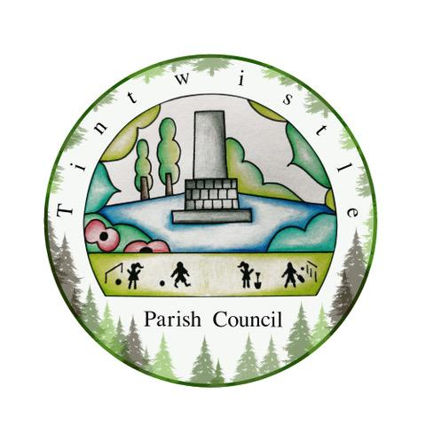**23rd July 2025**

Dear Tintwistle Staffing Committee,

You are hereby summoned to attend the meeting of Tintwistle Staffing Committee to be held on Wednesday 30th July 2025 at 5pm at the Council’s office.

**Tracy Lewis**

Tracy Lewis, Clerk to the Council

[tpcounciloffices@aol.com](mailto:tpcounciloffices@aol.com)

**AGENDA** (**MEMBERS OF THE PUBLIC AND PRESS ARE WELCOME TO ATTEND)**

1. **To receive apologies for absence**
2. **Declarations of interests**
3. **Public participation**: Up to 15 minutes will be made available for members of the public to raise matters relevant to the business of the Staffing Committee.
4. Exclusion of press & public: To consider this resolution: “That, in view of the confidential nature of the following agenda items, the press and public be excluded from the meeting, in accordance with the Public Bodies (Admission to Meetings) Act 1960, section 1.”
5. **Staff Pension Scheme -** To consider a report from the Clerk, select a pension scheme provider for council staff and agree employer and employee contribution rates.
6. **Date of the next meeting –** to be discussed